LOAN APPROVAL USING PREDICTIVE ANALYTICS

To minimize loss from the bank’s perspective, the bank needs a decision rule regarding who to give approval of the loan and who not to. An applicant’s demographic and socio-economic profiles are considered by loan managers before a decision is taken regarding his/her loan application. The Bank.data contains data on 9 input variables and the classification target indicating whether an applicant is considered a **Good or a Bad credit risk** for 1000 loan applicants. A predictive model developed on this data is expected to provide a bank manager guidance for making a decision whether to approve a loan to a prospective applicant based on his/her profiles.

The variables in this dataset are: • Age (numeric)

• Sex (categorical: male, female)

• Job (categorical: 0 - unskilled and non-resident, 1 - unskilled and resident, 2 - skilled, 3 - highly skilled)

• Housing (categorical: own, rent, or free)

• Saving accounts (categorical: little, moderate, quite rich, rich)

• Checking account (categorical: little, moderate, rich)

• Credit amount (numeric, in USD)

• Duration (numeric, in month)

• Purpose (categorical: car, furniture/equipment, radio/TV, domestic appliances, repairs, education, business, vacation/others)

• Target (categorical: 1 - Good, 0 - Bad)

data <- read.csv("~/Downloads/Bank.data.csv")  
head(data)

## ID Age Sex Job Housing Saving.accounts Checking.account Credit.amount  
## 1 0 67 male 2 own <NA> little 1169  
## 2 1 22 female 2 own little moderate 5951  
## 3 2 49 male 1 own little <NA> 2096  
## 4 3 45 male 2 free little little 7882  
## 5 4 53 male 2 free little little 4870  
## 6 5 35 male 1 free <NA> <NA> 9055  
## Duration Purpose Target  
## 1 6 radio/TV 1  
## 2 48 radio/TV 0  
## 3 12 education 1  
## 4 42 furniture/equipment 1  
## 5 24 car 0  
## 6 36 education 1

#formatting data  
data$Sex <- as.factor(data$Sex)  
data$Job <- as.factor(data$Job)  
data$Housing <- as.factor(data$Housing)  
data$Saving.accounts <- as.factor(data$Saving.accounts)  
data$Checking.account <- as.factor(data$Checking.account)  
data$Purpose <- as.factor(data$Purpose)  
data$Target <- as.factor(data$Target)  
  
data$Age <- as.numeric(data$Age)  
data$Credit.amount <- as.numeric(data$Credit.amount)  
data$Duration <- as.numeric(data$Duration)

summary(data)

## ID Age Sex Job Housing   
## Min. : 0.0 Min. :19.00 female:310 0: 22 free:108   
## 1st Qu.:249.8 1st Qu.:27.00 male :690 1:200 own :713   
## Median :499.5 Median :33.00 2:630 rent:179   
## Mean :499.5 Mean :35.55 3:148   
## 3rd Qu.:749.2 3rd Qu.:42.00   
## Max. :999.0 Max. :75.00   
##   
## Saving.accounts Checking.account Credit.amount Duration   
## little :603 little :274 Min. : 250 Min. : 4.0   
## moderate :103 moderate:269 1st Qu.: 1366 1st Qu.:12.0   
## quite rich: 63 rich : 63 Median : 2320 Median :18.0   
## rich : 48 NA's :394 Mean : 3271 Mean :20.9   
## NA's :183 3rd Qu.: 3972 3rd Qu.:24.0   
## Max. :18424 Max. :72.0   
##   
## Purpose Target   
## car :337 0:300   
## radio/TV :280 1:700   
## furniture/equipment:181   
## business : 97   
## education : 59   
## repairs : 22   
## (Other) : 24

#5 number summary for the credit amount (minimum, 1st quartile, median, 3rd quartile, maximum)  
summary(data$Credit.amount)

## Min. 1st Qu. Median Mean 3rd Qu. Max.   
## 250 1366 2320 3271 3972 18424

#correlation of Duration and Credit  
cor(data$Duration, data$Credit.amount)

## [1] 0.6249842

plot(data$Duration, data$Credit.amount)

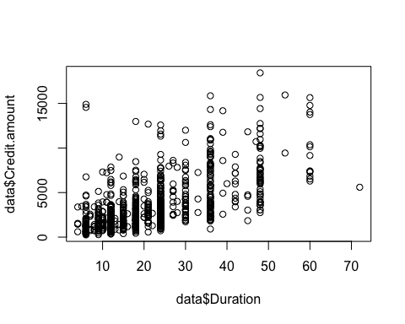 Variables are NOT highly correlated so we can keep both variables for the analysis (Usually, high correlation is considered above 0.75)

# Distribution of Credit amount for applicants considered as “Good” and “Bad” credit risk.  
  
boxplot(data$Credit.amount ~ data$Target, main ="Distribution of Credit amount", xlab = "0 - Bad 1 - Good", ylab = "Credit Amount", title = "xccc" , col = "lightblue")

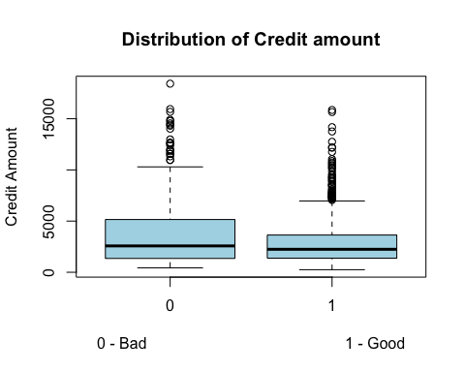

# table that contains the frequency of different housing types (free, own, rent) for “Good” and “Bad” instances.  
table(data$Housing, data$Target, useNA = "ifany", dnn= c("Housing", "Credit"))

## Credit  
## Housing 0 1  
## free 44 64  
## own 186 527  
## rent 70 109

#Renaming some variables  
names(data)[names(data) == "Checking.account"] <- "Checkings"   
names(data)[names(data) == "Saving.accounts"] <- "Savings"   
names(data)[names(data) == "Credit.amount"] <- "Credit"

### HANDLING MISSING VALUES

#Handling missing values  
library(mice)

## Warning: package 'mice' was built under R version 4.0.2

##   
## Attaching package: 'mice'

## The following objects are masked from 'package:base':  
##   
## cbind, rbind

md.pattern(data)



## ID Age Sex Job Housing Credit Duration Purpose Target Savings Checkings   
## 522 1 1 1 1 1 1 1 1 1 1 1 0  
## 295 1 1 1 1 1 1 1 1 1 1 0 1  
## 84 1 1 1 1 1 1 1 1 1 0 1 1  
## 99 1 1 1 1 1 1 1 1 1 0 0 2  
## 0 0 0 0 0 0 0 0 0 183 394 577

The output tells us that 522 samples are complete, 295 samples miss ONLY Checking.account, 84 samples miss only the saving.accounts and 99 samples miss both Saving.accounts and Checking.account.

#As far as categorical variables are concerned, replacing categorical variables is usually not advisable. Some common practice include replacing missing categorical variables with the mode of the observed ones, however, it is questionable whether it is a good choice.

#Since all NA values are from categorical variables:   
  
#REMOVE ALL ROWS WITH NA VALUES  
Data <- na.omit(data)  
sum(is.na(Data))

## [1] 0

### HANDLING OUTLIERS

library(dplyr)

##   
## Attaching package: 'dplyr'

## The following objects are masked from 'package:stats':  
##   
## filter, lag

## The following objects are masked from 'package:base':  
##   
## intersect, setdiff, setequal, union

boxplot(Data)

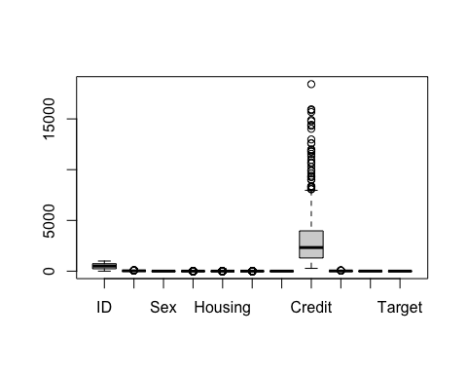

#credit variable  
credit_outliers = boxplot.stats(Data$Credit)$out # We first save all the outliers in the vector  
credit_outliers

## [1] 12579 14421 12612 15945 11938 10623 10961 8978 11998 10722 9398 9960  
## [13] 14782 14318 12976 11760 11328 8318 9034 8086 9857 14027 11560 8065  
## [25] 9271 9283 9629 15857 11816 15672 18424 14896 10297 8358 8386 8229

#duration variable  
Duration_outliers = boxplot.stats(Data$Duration)$out # We first save all the outliers in the vector  
Duration_outliers

## [1] 60 54 60 60 72 60 60 60

#REMOVING OUTLIERS FROM DATA  
Data<- Data[-which(Data$Duration %in% Duration_outliers),]  
Data<- Data[-which(Data$Credit %in% credit_outliers),]  
boxplot(Data)

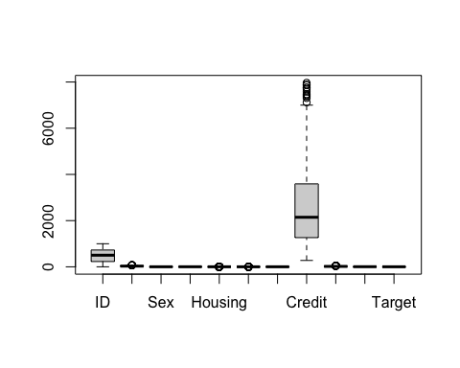

**Train/Test split**

set.seed(123)  
indx <- sample(2,nrow(Data), replace=TRUE, prob = c(0.7, 0.3))  
train <- Data[indx==1, ]   
test <- Data[indx==2, ]

### Logistic Regression Model using Forward Selection Technique

Forward Selection considers one variable at a time:

-If the variable improves the model (reduces AIC), we include it

-Otherwise, we don’t include it.

We look at r-squared, f-test or AIC.

We will check all possibilities from the null case to the full case

#Extreme Cases  
full <- glm(Target ~ . , data=Data, family = "binomial")  
null <- glm(Target ~ 1 , data=Data, family = "binomial")  
step(null, scope = list(lower=null, upper=full), direction="forward")

## Start: AIC=652.98  
## Target ~ 1  
##   
## Df Deviance AIC  
## + Duration 1 622.77 626.77  
## + Checkings 2 638.19 644.19  
## + Savings 3 640.57 648.57  
## + Housing 2 643.20 649.20  
## + Sex 1 648.04 652.04  
## + Age 1 648.46 652.46  
## + ID 1 648.80 652.80  
## <none> 650.98 652.98  
## + Credit 1 650.83 654.83  
## + Job 3 649.00 657.00  
## + Purpose 7 641.08 657.08  
##   
## Step: AIC=626.77  
## Target ~ Duration  
##   
## Df Deviance AIC  
## + Credit 1 609.26 615.26  
## + Checkings 2 612.15 620.15  
## + Sex 1 617.87 623.87  
## + Savings 3 614.97 624.97  
## + Housing 2 617.31 625.31  
## + ID 1 619.91 625.91  
## + Age 1 620.16 626.16  
## <none> 622.77 626.77  
## + Purpose 7 608.85 626.85  
## + Job 3 620.28 630.28  
##   
## Step: AIC=615.26  
## Target ~ Duration + Credit  
##   
## Df Deviance AIC  
## + Checkings 2 597.86 607.86  
## + Housing 2 601.96 611.96  
## + Savings 3 600.45 612.45  
## + Sex 1 605.29 613.29  
## + Purpose 7 594.51 614.51  
## + Age 1 607.10 615.10  
## <none> 609.26 615.26  
## + ID 1 607.27 615.27  
## + Job 3 608.57 620.57  
##   
## Step: AIC=607.86  
## Target ~ Duration + Credit + Checkings  
##   
## Df Deviance AIC  
## + Sex 1 593.64 605.64  
## + Housing 2 591.77 605.77  
## + Savings 3 590.55 606.55  
## <none> 597.86 607.86  
## + Age 1 595.87 607.87  
## + Purpose 7 583.96 607.96  
## + ID 1 596.39 608.39  
## + Job 3 597.12 613.12  
##   
## Step: AIC=605.64  
## Target ~ Duration + Credit + Checkings + Sex  
##   
## Df Deviance AIC  
## + Savings 3 585.88 603.88  
## + Housing 2 589.07 605.07  
## <none> 593.64 605.64  
## + Purpose 7 579.86 605.86  
## + Age 1 592.33 606.33  
## + ID 1 592.52 606.52  
## + Job 3 593.15 611.15  
##   
## Step: AIC=603.88  
## Target ~ Duration + Credit + Checkings + Sex + Savings  
##   
## Df Deviance AIC  
## + Housing 2 580.99 602.99  
## + Purpose 7 571.70 603.70  
## <none> 585.88 603.88  
## + Age 1 584.86 604.86  
## + ID 1 584.97 604.97  
## + Job 3 585.07 609.07  
##   
## Step: AIC=602.99  
## Target ~ Duration + Credit + Checkings + Sex + Savings + Housing  
##   
## Df Deviance AIC  
## <none> 580.99 602.99  
## + Age 1 579.73 603.73  
## + ID 1 580.19 604.19  
## + Purpose 7 568.19 604.19  
## + Job 3 579.85 607.85

##   
## Call: glm(formula = Target ~ Duration + Credit + Checkings + Sex +   
## Savings + Housing, family = "binomial", data = Data)  
##   
## Coefficients:  
## (Intercept) Duration Credit Checkingsmoderate   
## 0.2091507 -0.0728745 0.0002961 0.2653101   
## Checkingsrich Sexmale Savingsmoderate Savingsquite rich   
## 1.0498166 0.3809951 0.0592703 0.5239743   
## Savingsrich Housingown Housingrent   
## 1.5387266 0.4530058 -0.0441255   
##   
## Degrees of Freedom: 480 Total (i.e. Null); 470 Residual  
## Null Deviance: 651   
## Residual Deviance: 581 AIC: 603

AIC = −2log(Likelihood) + 2K

AIC = Residual deviance + 2 × number of parameters.

AIC is a single number score that can be used to determine which of multiple models is most likely to be the best model for a given dataset.

A lower AIC score is better.

“The Akaike information criterion (AIC) is an estimator of out-of-sample prediction error and thereby relative quality of statistical models for a given set of data. Given a collection of models for the data, AIC estimates the quality of each model, relative to each of the other models. Thus, AIC provides a means for model selection.”

#Log Regression with variables selected  
Log_Reg <- glm(Target ~ Duration + Credit + Checkings + Sex + Savings + Housing, family = "binomial", data = Data)  
  
predictions <- predict(Log_Reg, newdata = test, type="response")  
#probability of being in class GOOD  
Class <- ifelse(predictions >= 0.5 , 1, 0)  
  
#Confusion Matrix  
table(test$Target , Class, dnn=c("Predictions", "Actual"))

## Actual  
## Predictions 0 1  
## 0 23 26  
## 1 17 70

#accuracy function  
accuracy<- function(actual,predictions)  
{  
 y <- as.vector(table(predictions,actual))  
 names(y) <- c("TN","FP","FN","TP")  
 accuracy <- (y["TN"] + y["TP"])/ sum(y)  
 return(as.numeric(accuracy))  
}  
  
accuracy(test$Target, Class)

## [1] 0.6838235

summary(Log_Reg)

##   
## Call:  
## glm(formula = Target ~ Duration + Credit + Checkings + Sex +   
## Savings + Housing, family = "binomial", data = Data)  
##   
## Deviance Residuals:   
## Min 1Q Median 3Q Max   
## -2.1902 -1.1094 0.6413 0.9470 1.6766   
##   
## Coefficients:  
## Estimate Std. Error z value Pr(>|z|)   
## (Intercept) 2.092e-01 4.278e-01 0.489 0.624885   
## Duration -7.287e-02 1.250e-02 -5.828 5.62e-09 ***  
## Credit 2.961e-04 7.829e-05 3.782 0.000155 ***  
## Checkingsmoderate 2.653e-01 2.187e-01 1.213 0.225134   
## Checkingsrich 1.050e+00 3.693e-01 2.842 0.004478 **   
## Sexmale 3.810e-01 2.182e-01 1.746 0.080752 .   
## Savingsmoderate 5.927e-02 3.205e-01 0.185 0.853304   
## Savingsquite rich 5.240e-01 5.060e-01 1.036 0.300405   
## Savingsrich 1.539e+00 6.568e-01 2.343 0.019149 *   
## Housingown 4.530e-01 3.322e-01 1.364 0.172637   
## Housingrent -4.413e-02 3.787e-01 -0.117 0.907254   
## ---  
## Signif. codes: 0 '***' 0.001 '**' 0.01 '*' 0.05 '.' 0.1 ' ' 1  
##   
## (Dispersion parameter for binomial family taken to be 1)  
##   
## Null deviance: 650.98 on 480 degrees of freedom  
## Residual deviance: 580.99 on 470 degrees of freedom  
## AIC: 602.99  
##   
## Number of Fisher Scoring iterations: 4

We can see the significant variables with a *.

### DECISION TREE

library(rpart)

## Warning: package 'rpart' was built under R version 4.0.2

library(rpart.plot)

## Warning: package 'rpart.plot' was built under R version 4.0.2

tree_model <- rpart(Target ~ . , data=train)  
  
rpart.plot(tree_model)

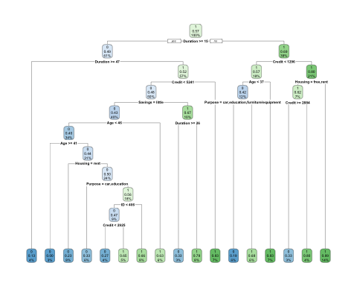 rpart(formula, data= train, parms= , control= )

control - controls how to split. control = rpart.control(minsplit=10)

minsplit = 10 -> at least 10 instances must be in each node so that it could be split further

minbucket = 10 -> min num of instances expected in terminal nodes

cp - complexity parameter -> is used to control the size of the decision tree and to select the optimal tree size.

want the tree with the min error & also min size of tree

* when cp is large – size of tree is small and error is larger
* when cp is small – size of tree is large and error is smaller

Example: rpart(y~., data, parms=list(split=c(“information”,“gini”)), cp = 0.01, minsplit=20, minbucket=7, maxdepth=30)

print(tree_model)

## n= 345   
##   
## node), split, n, loss, yval, (yprob)  
## * denotes terminal node  
##   
## 1) root 345 148 1 (0.4289855 0.5710145)   
## 2) Duration>=14.5 211 104 0 (0.5071090 0.4928910)   
## 4) Duration>=46.5 15 2 0 (0.8666667 0.1333333) *  
## 5) Duration< 46.5 196 94 1 (0.4795918 0.5204082)   
## 10) Credit< 5240.5 173 83 0 (0.5202312 0.4797688)   
## 20) Savings=little 137 59 0 (0.5693431 0.4306569)   
## 40) Age< 45.5 118 47 0 (0.6016949 0.3983051)   
## 80) Age>=40.5 10 0 0 (1.0000000 0.0000000) *  
## 81) Age< 40.5 108 47 0 (0.5648148 0.4351852)   
## 162) Housing=rent 26 6 0 (0.7692308 0.2307692) *  
## 163) Housing=free,own 82 41 0 (0.5000000 0.5000000)   
## 326) Purpose=car,education 21 7 0 (0.6666667 0.3333333) *  
## 327) Purpose=business,furniture/equipment,radio/TV,repairs,vacation/others 61 27 1 (0.4426230 0.5573770)   
## 654) ID< 406 32 15 0 (0.5312500 0.4687500)   
## 1308) Credit< 2925 15 4 0 (0.7333333 0.2666667) *  
## 1309) Credit>=2925 17 6 1 (0.3529412 0.6470588) *  
## 655) ID>=406 29 10 1 (0.3448276 0.6551724) *  
## 41) Age>=45.5 19 7 1 (0.3684211 0.6315789) *  
## 21) Savings=moderate,quite rich,rich 36 12 1 (0.3333333 0.6666667)   
## 42) Duration>=25.5 9 3 0 (0.6666667 0.3333333) *  
## 43) Duration< 25.5 27 6 1 (0.2222222 0.7777778) *  
## 11) Credit>=5240.5 23 4 1 (0.1739130 0.8260870) *  
## 3) Duration< 14.5 134 41 1 (0.3059701 0.6940299)   
## 6) Credit< 1296 63 27 1 (0.4285714 0.5714286)   
## 12) Age< 36.5 40 17 0 (0.5750000 0.4250000)   
## 24) Purpose=car,education,furniture/equipment 21 4 0 (0.8095238 0.1904762) *  
## 25) Purpose=business,domestic appliances,radio/TV,repairs 19 6 1 (0.3157895 0.6842105) *  
## 13) Age>=36.5 23 4 1 (0.1739130 0.8260870) *  
## 7) Credit>=1296 71 14 1 (0.1971831 0.8028169)   
## 14) Housing=free,rent 24 9 1 (0.3750000 0.6250000)   
## 28) Credit>=2884 9 3 0 (0.6666667 0.3333333) *  
## 29) Credit< 2884 15 3 1 (0.2000000 0.8000000) *  
## 15) Housing=own 47 5 1 (0.1063830 0.8936170) *

node), split, n, loss, yval, (yprob)

split- variable name & condition

n - number of instances on the node

loss - instances predicted in the wrong class

yval - predicted class

yprob - probability of being in each class [(x,y) first num x corresponds to the class predicted in the first node]

asteriks - terminal nodes

tree_pred_class <- predict(tree_model, test, type = "class")  
table(tree_pred_class, test$Target)

##   
## tree_pred_class 0 1  
## 0 18 26  
## 1 31 61

accuracy(tree_pred_class, test$Target)

## [1] 0.5808824

#To find best value of CP we can use printcp(), plotcp(), or summary() and choose CP with minimun xerror  
printcp(tree_model)

##   
## Classification tree:  
## rpart(formula = Target ~ ., data = train)  
##   
## Variables actually used in tree construction:  
## [1] Age Credit Duration Housing ID Purpose Savings   
##   
## Root node error: 148/345 = 0.42899  
##   
## n= 345   
##   
## CP nsplit rel error xerror xstd  
## 1 0.050676 0 1.00000 1.00000 0.062114  
## 2 0.033784 4 0.79730 1.06757 0.062529  
## 3 0.029279 5 0.76351 1.05405 0.062463  
## 4 0.020270 8 0.67568 1.03378 0.062348  
## 5 0.015766 9 0.65541 0.97973 0.061948  
## 6 0.010135 14 0.56081 1.01351 0.062215  
## 7 0.010000 16 0.54054 1.00000 0.062114

plotcp(tree_model)

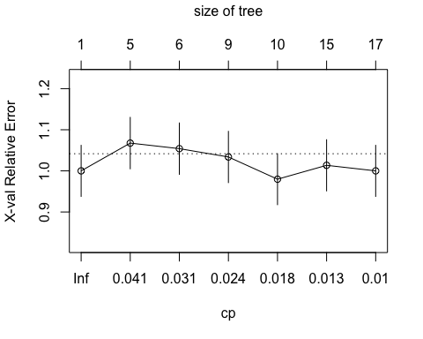 #### Tree with best CP value and minimum prediction error

optimal <- which.min(tree_model$cptable[ ,"xerror"])  
cp <- tree_model$cptable[optimal, "CP"]  
tree_pruned <- prune(tree_model, cp = cp)  
rpart.plot(tree_pruned)

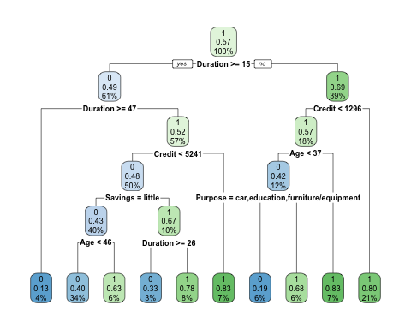

tree_pruned_pred_class <- predict(tree_pruned, test, type = "class")  
table(tree_pruned_pred_class, test$Target)

##   
## tree_pruned_pred_class 0 1  
## 0 24 30  
## 1 25 57

accuracy(tree_pruned_pred_class, test$Target)

## [1] 0.5955882

We can see accuracy increased by using best CP value

### SVM Model

First model with our selected values of cost and gamma

library(e1071)

## Warning: package 'e1071' was built under R version 4.0.2

svmModel<- svm(Target ~ . , data=train, type="C-classification", cost=100)  
summary(svmModel)

##   
## Call:  
## svm(formula = Target ~ ., data = train, type = "C-classification",   
## cost = 100)  
##   
##   
## Parameters:  
## SVM-Type: C-classification   
## SVM-Kernel: radial   
## cost: 100   
##   
## Number of Support Vectors: 239  
##   
## ( 112 127 )  
##   
##   
## Number of Classes: 2   
##   
## Levels:   
## 0 1

preds <- predict(svmModel, newdata=test)  
preds

## 4 8 10 13 16 28 33 35 39 42 52 55 60 68 95 102 112 113 126 128   
## 1 1 1 1 0 1 1 1 1 1 1 0 1 1 1 0 0 1 1 0   
## 129 130 138 141 157 164 167 168 180 192 195 196 204 213 214 219 240 258 262 274   
## 0 1 1 0 0 0 1 1 1 1 0 0 0 0 1 1 0 1 0 0   
## 285 287 300 310 313 339 345 347 356 363 368 389 392 397 399 426 439 458 462 463   
## 1 0 1 0 1 1 1 0 0 1 0 1 0 1 0 0 0 1 0 0   
## 467 471 480 501 503 513 516 517 519 530 538 539 540 544 557 563 566 567 575 596   
## 0 0 0 1 1 1 1 1 1 1 1 1 1 1 1 0 0 0 1 0   
## 597 598 601 605 606 611 612 628 635 640 645 647 651 656 660 665 667 691 704 710   
## 0 1 1 1 0 1 0 1 0 0 1 0 1 1 0 1 1 1 1 1   
## 721 728 731 738 748 753 757 763 767 775 780 789 791 794 812 814 816 824 836 851   
## 1 0 1 0 0 0 1 1 0 1 1 0 1 0 1 0 0 0 0 0   
## 875 886 891 897 924 926 927 930 951 952 953 958 976 980 986 999   
## 1 1 1 0 1 0 1 0 1 1 0 1 1 1 1 0   
## Levels: 0 1

table(test$Target, preds)

## preds  
## 0 1  
## 0 28 21  
## 1 30 57

accuracy(test$Target, preds)

## [1] 0.625

type = “C-classification” - binary classification

cost - cost of misclassification:

* if high-> not many misclassified points, margin can be small
* if low -> make more mistakes, margin is larger

Gamma defines how far the influence of a single training example reach.(influence of points either near or far away from the hyperplane.)

* Higher value of gamma → every point has close reach data → chance of overfitting, decision boundary looks wiggly.
* Low value of gamma → every point has far reach data → decision boundary looks smoother

to find best cost and gamma values, use cross validation

###### This function uses cv to find best value of gamma

Gamma in SVM is usually a value between 0 and 1

tunesvm <- tune(svm, Target ~. , data = train, kernel="radial", ranges = list(gamma = seq(.01, 0.1, by = .01), cost = 100, tunecontrol = tune.control(nrepeat = 10, sampling = "cross", cross = 10)))  
tunesvm

##   
## Parameter tuning of 'svm':  
##   
## - sampling method: 10-fold cross validation   
##   
## - best parameters:  
## gamma cost tunecontrol  
## 0.01 100 FALSE  
##   
## - best performance: 0.3911765

##### SVM Model using best gamma value obtained by doing CV

SVMmodel_tuned<- svm(Target~., data = train, type="C-classification" , cost = 100, gamma=0.01)  
predicted_svm <- predict(SVMmodel_tuned, newdata = test)  
  
accuracy(test$Target, predicted_svm)

## [1] 0.6691176

recall <- function(actual,predictions)  
{  
 y <- as.vector(table(predictions,actual))  
 names(y) <- c("TN","FP","FN","TP")  
 recall <- (y["TP"] / (y["TP"]+ y["FN"]))  
 return(as.numeric(recall))  
}  
  
 recall(test$Target, predicted_svm)

## [1] 0.7701149

precision <- function(actual,predictions)  
{  
 y <- as.vector(table(predictions,actual))  
 names(y) <- c("TN","FP","FN","TP")  
 precision <- (y["TP"] / (y["TP"]+ y["FP"]))  
 return(as.numeric(precision))  
}  
  
 precision(test$Target, predicted_svm)

## [1] 0.7282609

accuracy<- function(actual,predictions)  
{  
 y <- as.vector(table(predictions,actual))  
 names(y) <- c("TN","FP","FN","TP")  
 accuracy <- (y["TN"] + y["TP"])/ sum(y)  
 return(as.numeric(accuracy))  
}  
 accuracy(test$Target, predicted_svm)

## [1] 0.6691176

### NAIVE BAYES MODEL

naive_model <- naiveBayes(Target ~ ., data= train)  
naive_pred_class <- predict(naive_model, test, type="class", laplace =1)  
naive_pred_class

## [1] 0 0 1 1 1 1 1 1 1 1 1 0 0 1 1 0 0 1 1 1 1 1 1 1 1 1 1 1 1 0 0 1 0 1 1 0 1  
## [38] 1 1 0 1 0 1 1 1 0 1 1 1 1 0 1 1 1 1 1 0 1 1 1 0 1 1 0 1 1 1 1 1 1 1 0 1 1  
## [75] 1 1 0 1 1 1 0 1 1 1 1 1 1 1 1 0 1 0 0 0 1 1 1 1 1 1 1 0 1 1 1 1 1 1 0 1 1  
## [112] 0 1 1 1 0 0 1 1 0 1 0 1 0 1 1 0 1 1 0 1 1 1 1 0 0  
## Levels: 0 1

naive_pred_prob <- predict(naive_model, test, type="raw")  
  
#confusion matrix  
table(naive_pred_class, test$Target, dnn= c("Prediction", "Actual"))

## Actual  
## Prediction 0 1  
## 0 19 17  
## 1 30 70

accuracy(naive_pred_class, test$Target)

## [1] 0.6544118

#### Evaluation of Models using ROC Curves

library(ROCR)

## Warning: package 'ROCR' was built under R version 4.0.2

# 2 main functions: prediction & performance  
# prediction(True Labels, Predicted Probabilities for positive class)

##### ROC Curve for SVM model

svmModel1<- svm(Target ~ . , data=train, probability = TRUE, type="C-classification", gamma=0.01, cost=100, decision.values = TRUE)  
pred_svm <- predict(svmModel1, newdata=test, probability = TRUE, decision.values = TRUE)  
# returns predicted class, and probabilities of belonging on each class  
pred_prob_svm <- attr(pred_svm, "probabilities")  
# store results of the probabilities of being in each class  
pred_prob_svm_good <- pred_prob_svm[,2]   
# store prob of ONLY being in class 1 - Good  
pred <- prediction(pred_prob_svm_good, test$Target)  
  
#ROC CURVE CHART  
perf_roc_svm <- performance(pred, "tpr", "fpr")  
plot(perf_roc_svm)

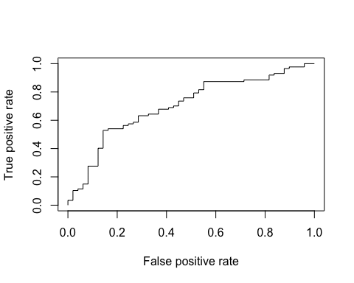

#AUC   
auc_svm <- performance(pred, "auc")  
auc_svm <- unlist(slot(auc_svm, "y.values"))  
auc_svm

## [1] 0.7037298

##### ROC Curve for Logistic Regression Model

pred_lr <- prediction(predictions, test$Target)  
perf_roc_lr <- performance(pred_lr, "tpr", "fpr")  
plot(perf_roc_lr)

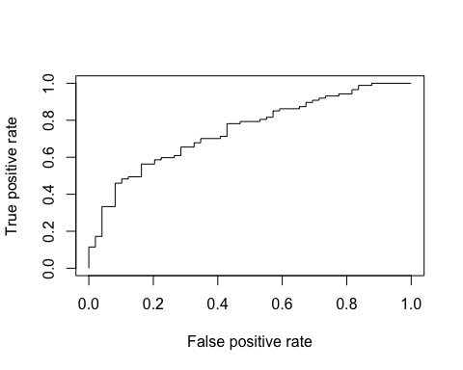

#AUC   
auc_LR <- performance(pred_lr, "auc")  
auc_LR <- unlist(slot(auc_LR, "y.values"))  
auc_LR

## [1] 0.7447807

##### ROC Curve for Decision Tree Model

tree_pruned_pred_probs <- predict(tree_pruned, test)   
#probability of being in each class  
tree_pruned_pred_probs_positive <- tree_pruned_pred_probs[,2]   
#probability of being in class 1-Good  
  
pred_decision_tree <- prediction(tree_pruned_pred_probs_positive, test$Target)  
perf_roc_decision_tree <- performance(pred_decision_tree, "tpr", "fpr")  
plot(perf_roc_decision_tree)

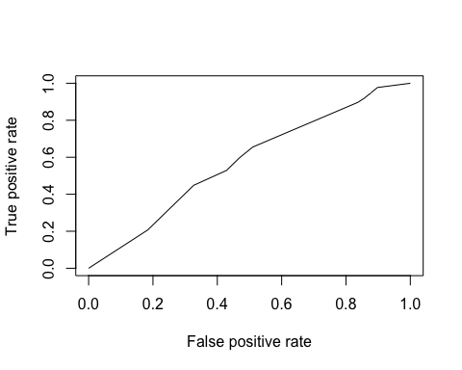

#AUC  
auc_DT <- performance(pred_decision_tree, "auc" )  
auc_DT <- unlist(slot(auc_DT, "y.values"))  
auc_DT

## [1] 0.575651

##### ROC Curve for Naive Bayes Model

naive_pred_prob_yes <- naive_pred_prob[,2]  
pred_nb <- prediction(naive_pred_prob_yes, test$Target)  
perf_roc_nb <- performance(pred_nb, "tpr", "fpr")  
plot(perf_roc_nb)

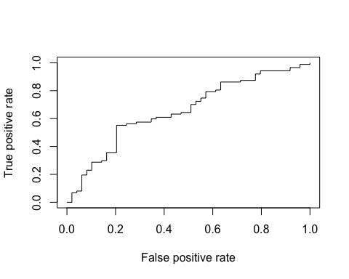

#AUC   
auc_NB <- performance(pred_nb, "auc")  
auc_NB <- unlist(slot(auc_NB, "y.values"))  
auc_NB

## [1] 0.6572836

Overall, our Logistic Regression Model is performing better than SVM, DT, and Naive Bayes.

The accuracy of the Logistic Regression Model: 0.6838235, AUC: 0.7447807

The accuracy of the SVM: 0.6691176 , AUC: 0.7037298

The accuracy of the DT: 0.5955882 , AUC:0.575651

The accuracy of the NB: 0.6544118 , AUC:0.6572836